**JavaScript Custom Functions**

**Functions:**

A function is made up of related code that performs a particular task. For example, a function could be written to calculate area given width and height. The function can then be called elsewhere in the script, or **when an event fires.**

Functions are either written in the <head> element or in an external file that is linked from inside the <head> element, which means that **they can be reused** in several places within the page.

**How to Define a Function:**

There are three parts to creating or defining a function:

* Define a name for it.
* Indicate any values that might be required; these are known as arguments.
* Add statements to the body of the function.

For example, if you want to create a function to calculate the area of a rectangle, you might name the function calculateArea() (note that a function name should be followed by parentheses). In order to calculate the area, you need to know the rectangle’ s width and height, so these would be passed in as *arguments* (arguments are the information the function needs to do its job). Inside the body of the function (the part between the curly braces) are the *statements,* which indicate that area is equal to the width multiplied by the height (both of which have been passed into the function). The area is then returned.

function calculateArea(width, height) {

area = width * height

return area

}

If a function has no arguments it should still have parentheses after its name — for example, you might have a function that will run without any extra information passed as an argument such as, logOut().

**How To Call a Function:**

The clickMe() function does nothing sitting on its own in the head of a document; it has to be *called*. In this example, you can call the function from a simple form using the onclick event, so that when the user clicks the button the “Nepal Idol” text will be changed to “VOICE OF NEPAL”.

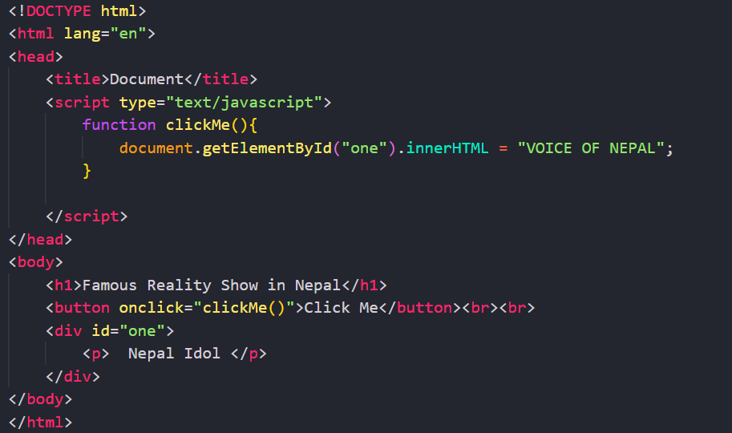

**The Return Statement:**

Functions that return a result must use the return statement. This statement specifies the value that will be returned to where the function was called. The calculateArea() function, for example, returned the area of the rectangle:

function calculateArea(width, height) {

area = width * height

return area

}

What is returned depends on the code inside the function; for example, our area function will return the area of the rectangle. By contrast, if you had a form where people could enter an e - mail address to sign up for a newsletter, you might use a function to check whether that person had entered a valid e-mail address before submitting the form. In that case, the function might just return true or false values.

What happens when the value is returned depends on how the function was called. With our function to calculate area, we could display the area to the user with some more JavaScript code. If we were checking whether an e - mail address was in a valid format before subscribing that e - mail address to a newsletter, the return value would determine whether the form was submitted or not.